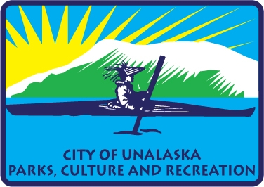

**City of Unalaska | Department of Parks, Culture and Recreation**

**Advisory Committee Meeting Minutes for April 21, 2025**

Members present Thomas Roufos, Chair, Greg Peters, Ben Knowles, Kim Hankins.

The Parks Culture and Recreation Advisory Board meeting was called to order at 5:30 PM on April 21, 2025, at the Conference Room at PCR.

Recognize visitors at the meeting, Jolene Longo, Jackie Adams

**New Business**

The Advisory Board Chair asked to have an item added to the Agenda on Social Districts. Ben moved to add the item to the agenda, and Kim seconded, and the vote was unanimous. The item was added to the agenda for discussion.

$200,000 Feasibility Study-- Roger explained that the Parks Culture and Recreation Administrative operating budget for fiscal year 2026 included a line item for a feasibility study for the pool/multi-purpose facility. Sometime in the summer, PCR will develop an RFP to bring on a consultant to help determine the best course of action needed for the Pool and possible multi-use facility.

Business Plans for all the different sections of PCR were reviewed by the Advisory Board. Roger explained how the Business Plans worked and how it was a way to explain the operations of the Department to anyone who wanted to understand what programs and budgets were proposed to City Council. This gives us a snapshot of the organization each year and it is a report card of the achievements and progress we are making.

Start of the Soft Ball season status of infield mix-Public Works. Jolene reported that Public Works was looking to see how much money they would have to buy an additional infield mix for this year, Marc, was aware of our need to get the infield mix here before the start of the season. We will also have to seed the field again. Volunteers would be needed in this process. Bases and the home-plate would need to be relined so that the geometry was correct for the bases. Jolene reported that she is looking for a part to arrive to fix the score board. The score board would be upgraded to blue tooth.

Social District, Thomas presented to the Advisory Board a Draft Letter for City Council asking them to consider a Social District. The letter was reviewed by the Board and Thomas believes that this is the start of the process of having an ordinance change. This might not happen this season if the City Council and or the City Attorneys have problems with a social district. Thomas will submit the letter to City Council at the public announcements May 11, 2025.

Concession-stand small appliances, Jolene said that we had purchased some small appliances for the kitchen at Kelty Field. They included a hot dog roller, pizza warming oven, air fryer, and we would move the popcorn machine over to the kitchen for the soft ball season.

Grants, Jackie Adams, the Grants Writer for the City, reported that she had worked with PCR and had submitted a grant for USA Swimming for $10,000. She also had submitted a grant for park amenities for $47,764. She was also going to meet with the Recreation Staff on an Arts and Culture grant to be submitted in June. She is also looking to submit a grant for Little League for equipment.

**Old Business**

**Committee Members Comments**

The easter event was great. Ben suggested we rekey the small door by the shed at Kelty Field so it can be used.

**Next Meeting is May 19, 2025.**

**Adjournment at 7:35 p.m.**