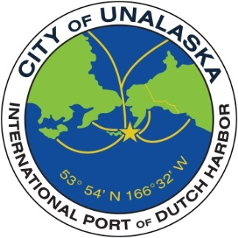

CITY OF UNALASKA
International Port of Dutch Harbor
Alaska

Parks, Culture and Recreation Director

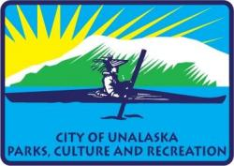
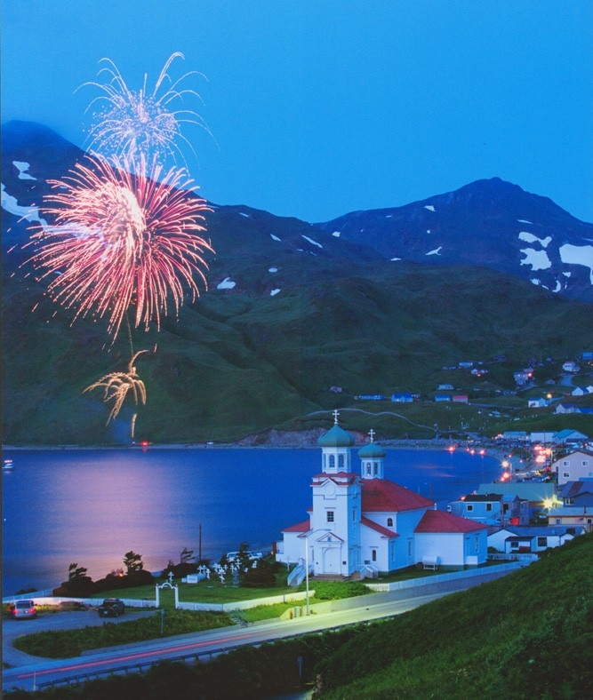

43 Raven Way · P. O. Box 610 · Unalaska, Alaska 99685
(907) 581-1251 · www.ci.unalaska.ak.us
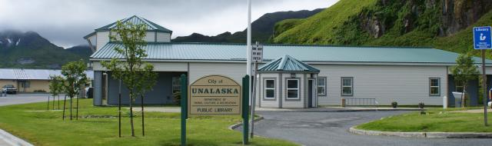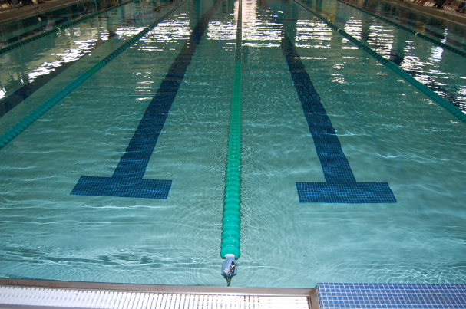
WHY APPLY?
The City of Unalaska is a well-financed and professionally run organization, staffed by hardworking, talented and successful people. City facilities are well-maintained, and we have a history of numerous and successful capital projects. This position will provide many challenges and the opportunity to grow professionally. The City’s Parks, Culture and Recreation department truly represents the heartbeat of the community providing both indoor and outdoor recreation and cultural opportunities that all can enjoy.
COMMUNITY PROFILE
The City of Unalaska is located on an island of the same name, located in the Aleutian Chain off the west coast of Alaska. We are 800 miles southwest of Anchorage, which is a 3 hour flight, and have a population of about 4,700. Our community is a vibrant mix of industry and history connected by 40 miles of roads linking our port, harbors and private docks with local businesses and our thriving residential community.
Unalaska is on the coast of Unalaska and Amaknak Islands and is home to one of the busiest and most prosperous stretches of coastline in Alaska. For more than 30 years, Unalaska’s economy has been based on commercial fishing, seafood processing, fleet services and marine transportation. The Port of Dutch Harbor is the only deep draft, year-round ice-free port from Unimak Pass west to Adak and north to the Bering Straits. Our Port has been designated a “Port of Refuge” and provides protection and repair for disabled or distressed vessels as well as ground and warehouse storage and transshipment opportunities for the thousands of vessels that fish or transit the waters surrounding the Aleutian Islands on a daily basis.
Unalaska is the anchor for commercial fishing activity in the Bering Sea and the Aleutian Islands and is the #1 commercial fishing port in the United States, based on the quantity of the catch, a distinction held for more than 20 years.
Unalaska is also the home of the western-most container terminal in the United States and is one of the most productive ports for transshipment of cargo in Alaska. In addition to product shipped domestically to and from this regional hub, product is shipped to ports around the world with weekly shipments headed to Europe and Asia by container ship and freighter.
Unalaska is unique among Alaska’s coastal communities in the support services provided. In addition to the five seafood processing facilities in Unalaska, the business community provides a wide range of support services including accounting and bookkeeping, banking, cold storage, construction and engineering, diesel sales and service, electrical service and marine electronics, equipment, freight forwarding, gear replacement and repair, hydraulic services, logistical support, marine pilots and tugs, maritime agencies, stevedoring, trucking, vehicle rental, vessel repair, warehousing and welding. Because of the wide variety of services provided each and every day, no other community in the region has Unalaska’s capacity to support commercial fishing in the Bering Sea.
With the transient nature of the community due in part to the cyclical nature of the fishing industry and the shortage of available housing, the department of Parks, Culture and Recreation has provided a dependable and reliable service to the community by offering unique activities and opportunities suited both for permanent and temporary residents of the community.
The people of Unalaska take pride not only in the work they do, but in the quality of their schools, health care and their leisure and cultural opportunities.
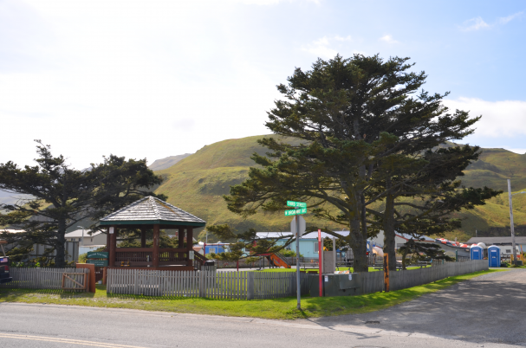
The Unalaska City School District operates two schools providing a well-rounded educational experience for students from preschool through 12th grade. Unalaska City Schools have consistently ranked among the top school in the state in academics. Unalaska City School was awarded the National Blue Ribbon School Award in 2011, and in 2012 Eagle’s View Elementary was nominated for this prestigious award. Our school system has excellent facilities, modern instructional technology and a wide variety of academic and co-curricular programs.
Health care is provided primarily by Iliuliuk Family & Health Services, which operates a local clinic providing the community with comprehensive primary medical care, behavioral health care and dental care. There are two excellent chiropractic offices on the island, as well as visiting dentists and optometrists.
Unalaska’s weather is fairly moderate, with an average summer temperature range of °41-52, and a winter average of °31-40. We receive about 60” of precipitation each year, but with our relatively warm winter temperatures, any snow doesn’t stay on the ground for long in town. In summer, our hills turn a vibrant green and are blanketed with beautiful wildflowers and berries.
Ounalashka Corporation is the major land owner on Unalaska, Amaknak and Sedanka Islands and graciously opens their land, within reason, for use in subsistence and recreational activities including salmon fishing, gathering foods in the intertidal zone (such as clams, mussels, sea urchins, chitons, seaweeds, etc.), collection of greens and herbs, berry picking, hiking and wildlife viewing. Hiking along the miles of World War II roads, and trails once traveled by ancient peoples, allows Unalaskans the opportunity to get away from it all by wandering through history that is hidden in the most exquisite beauty nature has to offer – and no bears! Residents and visitors alike enjoy year round outdoor activities.
Our island is also home to two excellent museums, one focusing on WWII in the Aleutians and the Museum of the Aleutians promotes public awareness of the rich cultural legacy of the people of the Aleutian Islands.
There are numerous nonprofit agencies serving the community which provide volunteer opportunities and the chance to grow and network within the community.
THE CITY
Unalaska has a Council, strong City Manager form of government. The elected Mayor and City Council are responsible for the legislative functions of the City, developing overall vision, establishing policy, passing local ordinances and voting on budget appropriations. The city’s seven elected officials provide sound direction and stable, progressive leadership. The City Council appoints a professional City Manager who has broad authority to oversee the administrative operations of the municipality, implement policies and advise the Mayor and City Council. The City is not part of an organized borough.
The City is comprised of nine departments: Administration; Clerks; Planning; Finance; Public Safety; Ports; Public Works; Public Utilities and Parks, Culture and Recreation. Each department has a designated director that directs the overall operations of the department including personnel and budget, the Parks, Culture and Recreation staff is comprised of approximately 30 full time and part time staff with an FY17 budget of $1,906,424. The Parks, Culture and Recreation Director works with other department directors as the City’s leadership team to further the mission of the City by providing quality services to the community.
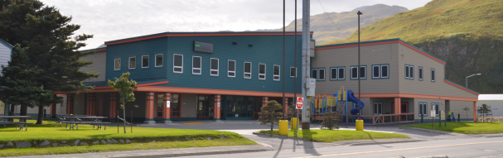
THE POSITION
This executive level position, under the general supervision of the City Manager, is responsible for the day to day operations of the Department of Parks, Culture and Recreation. The Department of Parks, Culture and Recreation is staffed by approximately 30 employees, including community center, library and aquatics center employees. The Department is also responsible for the oversight of the City’s eight parks which include four parks with active playgrounds, a skateboard park, a multi-use open space used for a variety of recreational events and a softball field with a concession stand.
The City’s Department of Parks, Culture and Recreation provides year round classes, activities and events for the entire family, and the Public Library has been named a Star Library every year since 2007.

EXAMPLES OF WORK:
- Plans and organizes workloads and assignments for all staff with direct supervisory responsibilities over the PCR Management Team: Recreation Manager, Operations and Facilities Manager, Aquatics Manager and Librarian
- Prepares annual operating, personnel, and capital project budget requests and provides planning and budgetary information to the City Council
- Provides leadership for the development and implementation of department’s short and long-range plans as directed by the City Manager
- Facilitates and supports the activities of the City’s appointed Parks, Culture and Recreation Advisory Board and Library Advisory Committee
- Promotes interest in department programs while ensuring effective and efficient use of budgeted resources
- Directs and motivates staff toward the accomplishment of program objectives

KNOWLEDGE, SKILLS AND ABILITIES:
- Must possess thorough knowledge of the principles and practices of a modern parks and recreation program and the required equipment and facilities
- Demonstrated ability to understand and manage a department budget
- Possess and understanding of personnel management including employee development, adherence to a labor union contract, employee performance evaluations, coaching and progressive disciplinary processes
- Ability to establish and maintain productive working relationships with subordinates, peers, employees, elected officials and members of the public
- Demonstrated leadership and management skills

EXPERIENCE AND EDUCATION:
Graduation from an accredited four-year college or university with a Bachelor degree in recreation administration or similar field. Certified Park and Recreation Professional (CPRP) preferred. Minimum of seven years professional experience in parks and recreation programs with five years supervisory experience. Alaska experience preferred. Other combinations of education and experience providing the knowledge, skills and abilities will be evaluated on an individual basis.

IDEAL CANDIDATE PROFILE
Unalaska is looking for a leader and manager who understands all aspects of a municipal parks and recreation department including experience with public libraries and multi-cultural communities. He or she will have had previous experience in an organization of similar size and complexity recognized for excellent customer service and continuous improvement. The ideal candidate will have excellent skills in working collaboratively with eight Department Directors and a diverse make-up of subordinate staff and will have a proven track record of delivering results, building accountability for staff and creating a positive working environment.
The City of Unalaska most recent Parks, Culture and Recreation Director was on the job for nearly 11 years. The City Manager is seeking a Director who is excited to live in Unalaska and who can give a long-term commitment. The successful candidate will have a proven track record of conservative budget and financial management, demonstrate the ability to administer people and budgets, make sound management decisions, and initiate work without direct supervision.
Unalaska seeks a Parks, Culture and Recreation Director who will continue our positive organizational culture. He or she will model respect for others and a spirit of collaboration and cooperation. The ideal candidate will be personable and accessible to employees and the public and be comfortable in a professional, yet informal, work place.
Because of the current strength of the City’s Parks, Culture and Recreation Department, the City Manager is not seeking an individual intent on major or immediate changes. The ideal candidate will be prepared to first take time to listen, learn and build relationships, both within the organization and in the community.
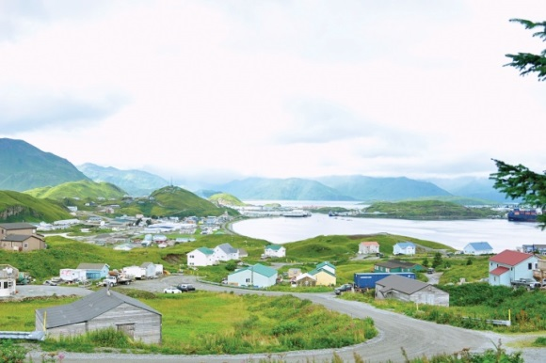COMPENSATION AND BENEFITS
- Salary Range: $84,826-135,722 (Wage based on the midpoint of the wage scale: $110,274)
- $1,500 Annual Airfare Allowance
- Generous Personal Leave, accruing at the following rates:

Years 1-2: 16 hours per month

Years 3-4: 20 hours per month

Years 3-4: 20 hours per month

Years 5-6: 24 hours per month

Years 7-8: 28 hours per month

Year 9-on: 32 hours per month
- Nine paid holidays per year, plus 3 floating holidays
- Bereavement leave
- State of Alaska Public Employees Retirement System (PERS)
- Health insurance (medical, dental, vision and audio) at no cost to employee and dependents
- $5,000 life insurance policy with optional term policies available
- 457 Plans
- AFLAC: Voluntary additional medical insurance available to employee at own expense.
- No Alaska state income tax

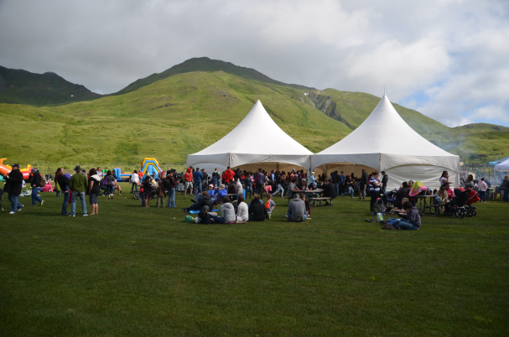

TO APPLY

If the idea of becoming part of a dedicated team of professionals living in a community with a thriving economy and quality of life like no other, please submit a City of Unalaska Employment Application, cover letter, resume, five professional references to:

CITY OF UNALASKA
Attention: Director of Parks, Culture and Recreation Search
C/O Human Resources Department
P.O. Box 610
Unalaska, Alaska 99685

Applications are available on our website at www.ci.unalaska.ak.us. Applications submitted through Indeed.com will not be considered.

For questions concerning the application process or for additional information about the position or the community please contact Human Resources Manager Kelly Stiles at (907) 581-1251, extension 1302, or by email to kstiles@ci.unalaska.ak.us.

The City of Unalaska is an Equal Opportunity/AA employer.

Qualified candidates are strongly encouraged to apply by October 14, 2016, for first review, though the position will remain open until filled.

